Code -collections

1. Two Sum
Given an array of integers nums and an integer target, return indices of the two numbers such that they add up to target.
You may assume that each input would have exactly one solution, and you may not use the same element twice.
You can return the answer in any order.

Example 1:
Input: nums = [2,7,11,15], target = 9
Output: [0,1]
Explanation: Because nums [0] + nums [1] == 9, we return [0, 1].

Example 2:
Input: nums = [3,2,4], target = 6
Output: [1,2]

Example 3:
Input: nums = [3,3], target = 6
Output: [0,1]

Solution:
class Main {
public static void main(String[] args) {
int[] arr = {2, 7, 11, 15};
int target = 9;

for (int i = 0; i < arr[i]; i++) {
for (int j = i + 1; j < arr[j]; j++)
{
if (arr[i] + arr[j] == target) {
System.out.println("\n hence the Array will be : [" + arr[i] + ", " + arr[j] + "]");
System.out.println("AT Index: [" + i + ", " + j + "]");
return;
}
}
}

System.out.println("No solution found.");
}
}
---------------------------------------------------------------------------------------------------------

Given an integer x, return true if x is a
palindrome
, and false otherwise.

Example 1:

Input: x = 121
Output: true
Explanation: 121 reads as 121 from left to right and from right to left.
Example 2:

Input: x = -121
Output: false
Explanation: From left to right, it reads -121. From right to left, it becomes 121-. Therefore it is not a palindrome.
Example 3:

Input: x = 10
Output: false
Explanation: Reads 01 from right to left. Therefore it is not a palindrome.
https://leetcode.com/problems/palindrome-number.

Solution:

class Solution {
public boolean isPalindrome(int x) {
if (x < 0) {
return false;
}
int temp = x, rev = 0;
while (x > 0) {
int rem = x % 10;
rev = rev * 10 + rem;
x = x / 10;
}
return temp == rev;
}
}
You are given a string s consisting of lowercase English letters, and an integer k. Your task is to convert the string into an integer by a special process, and then transform it by summing its digits repeatedly k times. More specifically, perform the following steps:
1. Convert s into an integer by replacing each letter with its position in the alphabet (i.e. replace 'a' with 1, 'b' with 2, ..., 'z' with 26).
2. Transform the integer by replacing it with the sum of its digits.
3. Repeat the transform operation (step 2) k times in total.
For example, if s = "zbax" and k = 2, then the resulting integer would be 8 by the following operations:
1. Convert: "zbax" ➝ "(26)(2)(1)(24)" ➝ "262124" ➝ 262124
2. Transform #1: 262124 ➝ 2 + 6 + 2 + 1 + 2 + 4 ➝ 17
3. Transform #2: 17 ➝ 1 + 7 ➝ 8
Return the resulting integer after performing the operations described above.

Example :
Input: s = "zbax", k = 2
Output: 8

class Main {
public static void main(String[] args) {
String[] str = {"zbax"};
int k = 2;

int result = trString(str[0], k);
System.out.println("The sumof (53=5+3) is: "+result);
}
public static int trString(String str, int k) {
int n = 0;

for (int i = 0; i < str.length(); i++) {
n += (str.charAt(i) - 'a' + 1);
}

for (int i = 0; i < k; i++) {
n = digitSum(n);
}

return n;
}
public static int digitSum(int n) {
int sum = 0;

while (n > 0) {
sum += n % 10;
n /= 10;
}

return sum;
}
}

4
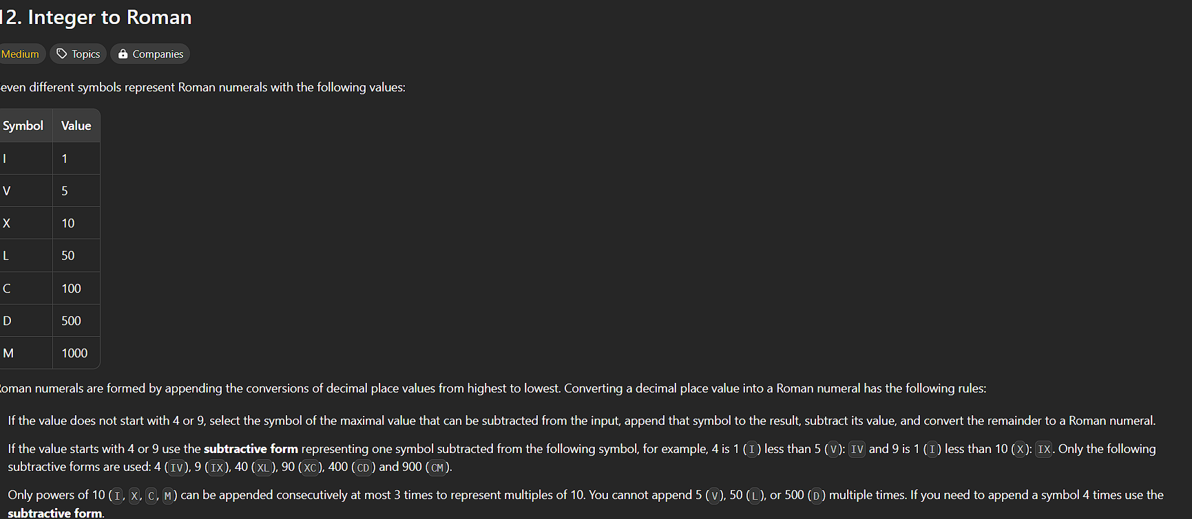

https://leetcode.com/problems/integer-to-roman

https://leetcode.com/problems/integer-to-roman

Solution:
public class Solution {
public String intToRoman(int num) {
int[] val = {1000, 900, 500, 400, 100, 90, 50, 40, 10, 9, 5, 4, 1};
String[] symbols = {"M", "CM", "D", "CD", "C", "XC", "L", "XL", "X", "IX", "V", "IV", "I"};
StringBuilder roman = new StringBuilder();
for (int i = 0; i < val.length; i++) {

while (num >= val[i]) {
roman.append(symbols[i]);
num -= val[i];
}
}
return roman.toString();
}
}

Note: had referred gpt in order to take help to append the string without creating the new function for it .

